**Ik kan**

[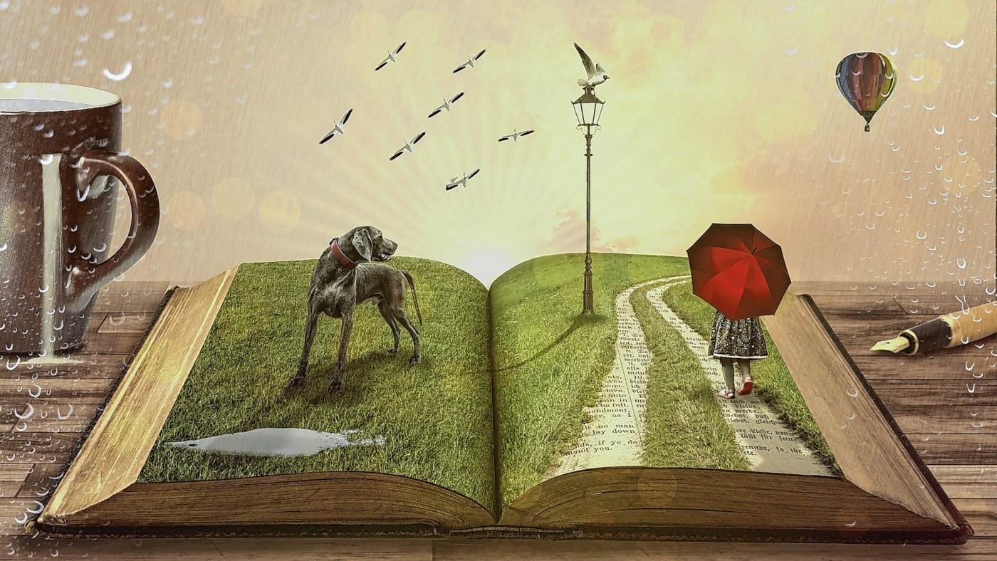](http://www.google.be/url?sa=i&rct=j&q=&esrc=s&source=images&cd=&cad=rja&uact=8&ved=2ahUKEwjQt4zQ7ObbAhWDalAKHa2QDwMQjRx6BAgBEAU&url=http%3A%2F%2Fdestadamersfoort.nl%2Fdeel-je-nieuws-activiteit%2Fworkshop-klankverhaal-als-inspiratie-voor-levenskunst-321832&psig=AOvVaw0wKE7wEMVyj7HdLrMBbq5w&ust=1529742360373894)

**een klankverhaal maken**

**Ik kan**

[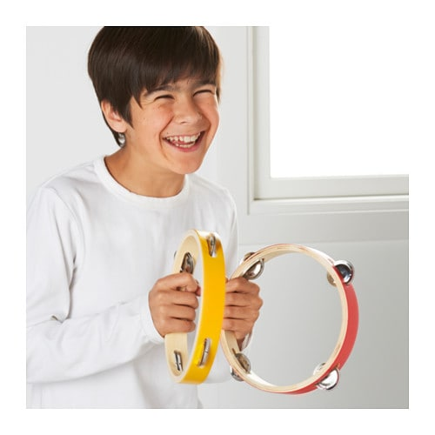](https://www.google.be/url?sa=i&rct=j&q=&esrc=s&source=images&cd=&cad=rja&uact=8&ved=2ahUKEwiD2pO97ubbAhUJJVAKHRzKDC0QjRx6BAgBEAU&url=https%3A%2F%2Fwww.ikea.com%2Fnl%2Fnl%2Fcatalog%2Fproducts%2F90310258%2F&psig=AOvVaw3tVvoSAdmhzCdnonGgzmu4&ust=1529742877118454)

**improviseren**

**Ik kan**

[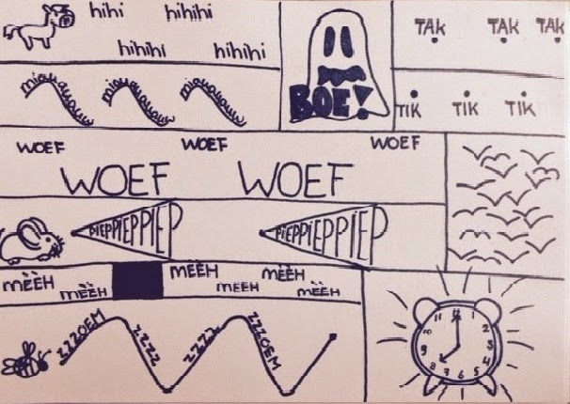](http://www.google.be/url?sa=i&rct=j&q=&esrc=s&source=images&cd=&ved=2ahUKEwj0ooXh7ubbAhUPLVAKHRA5BAkQjRx6BAgBEAU&url=http%3A%2F%2Frosalievlastuin.blogspot.com%2F2014%2F11%2Fdrama-grafisch-partituur.html&psig=AOvVaw0iOfwItgwgNaz1qrr8f1ng&ust=1529742941907142)

* met hulp
* zelfstandig

**componeren**